

Colegio Tecnológico Pulmahue

SEGUNDO MEDIO
Name:
El objetivo de esta guía es que los estudiantes identifiquen acciones y objetos para protegerse de accidentes en la via y también reconocer las distintas señales que existen en las reglas del tránsito.

Para dudas que tengan pueden escribirme un correo a esta dirección: yorka.sepulveda.pulmahue@gmail.com, escribiendo en el asunto el nombre de él o la estudiante y su curso, el horario para correos es de 9am a 7pm. Cualquier consulta sobre los contenidos y asignatura será respondida y también en caso de que necesiten material extra.

O.A: Identificar vocabulario sobre elementos de protección en la vía publica y señales del tránsito.

I. READ THE FOLLOWING STORY IDENTIFY THE WORDS IN BOLDS IN THE WORDSEARCH

Cycling Around

John was talking to Miranda about cycling to football on Saturday. Miranda asked if he thought it a good idea. John replied he had completed his cycle proficiency test and been out with his dad for a number of rides and that for his birthday he had received a new cycle helmet.
Miranda asked what he was going to wear. He replied that he was going in the same clothes as he had on now but that he would be adding some reflective arm and leg bands and a high visibility vest to make him visible to other road users. Miranda wished him all the best and went on her way.
On Saturday John arrived safely at the football match and his team won 4-2.

See if you can find the words in BOLD in the grid below. Remember the words can be in any order up or down. Good Luck

t | s | c | r | e | o | d | d | t | i | t
c | o | m | p | l | e | t | e | d | y | h
e | n | t | t | t | m | i | i | m | t | e
l | n | l | y | e | n | c | e | l | v | l
v | t | e | t | e | s | t | r | l | v | m
r | e | f | l | e | c | t | i | v | e | e
v | i | s | i | b | l | i | l | i | y | t
c | y | c | l | e | a | r | m | l | c | b
o | f | f | m | c | y | f | i | y | o | p
p | r | o | f | i | c | i | e | n | c | y
c | y | c | l | i | n | g | e | v | d | v

II. NOW, SEARCH THE MEANING OF THE WORDS, YOU CAN USE A DICTIONARY OR AN ONLINE TRANSLATOR.

CYCLING:
PROEFICIENCY TEST:
HELMET:
REFLECTIVE ARM:
VISIBILITY:

ANSWER THESE QUESTIONS:

1.Why do you think it is important to use or wear the security elements of the text?

2. What others security elements would you add to protect your life from road accidents?

3. Do you use these elements when you ride a bike?

III. LOOK AT THE FOLLOWING IMAGES AND WRITE THEIR MEANING.
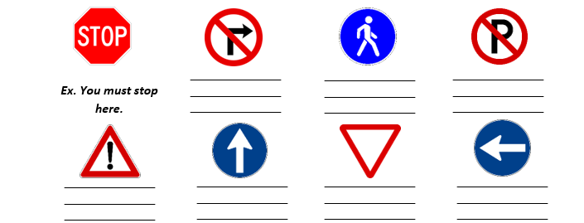

Give away – stop here – turn left – go straight – walk here – turn right – park here – be careful

